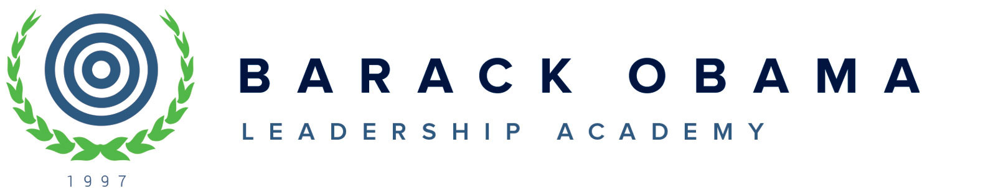
10800 E. Canfield
Detroit Mi 48214
(313) 823-6000/ Fax (313) 823-9748

Board of Directors Meeting Cancellation Notice

September 26, 2023

Dear Board Members,

The Wednesday, September 27, 2023 Board of Directors Meeting has been cancelled and will be re-scheduled. Notice will go out when the date is finalized. Thank you for all you do.

We look forward to seeing you and appreciate that you are a member of the BOLA Board of Directors this 2023/2024 school year. If you have any questions regarding this notice, contact Monique Philpot; Monday thru Friday, 7:30A.M. until 4:30P.M. at 313-823-6000 or at mailto:mphilpot@obamaacademy.org

Asante, (Thank You)

Monique Philpot

