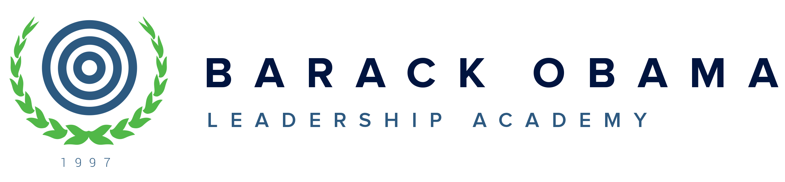

10800 E. Canfield (313) 823-6000 Phone
Detroit, MI 48214 (313) 823-9748 Fax

District Annual Education Report (AER) Cover Letter

February 9, 2024

Dear Parents and Community Members:

We are pleased to present you with the Annual Education Report (AER) which provides key information on the 2022-23 educational progress for Barack Obama Leadership Academy. The AER addresses the complex reporting information required by federal and state laws. The school’s report contains information about student assessment, accountability, and teacher quality. If you have any questions about the AER, please contact Principal, Jerrel Anthony, or Assessment/Data Coach, Yvette Eddie for assistance.

The AER is available for your review electronically by visiting the following links: https://www.obamaacademy.org or https://www.mischooldata.org/annual-education-report-1?Common_Locations=1-S,11600,1600,119 You may also review a copy in the main office at the school.

Student Assessment Data
- Includes the following three assessments: M-STEP (Michigan Student Test of Educational Progress), MI-Access (Alternate Assessment), and College Board SAT
- Presents assessment information for English language arts and mathematics for grades 3 to 8 and 11, and MI-Access science for grades 4, 7, and 11, compared to state averages for all students as well as subgroups of students.

School Accountability Data
- Includes information on schools’ performance on various measures such as student proficiency and growth on state assessments, graduation, and attendance rates. Performance is measured on 0-100 index scales
- Reports schools identified under three federally required categories for further support: Comprehensive Support and Improvement, Targeted Support and Improvement, and Additional Targeted Support

Educator Qualification Data
- Identifies the number and percentage of inexperienced teachers, principals, and other school leaders
- Reports teachers who are teaching with emergency or provisional credentials
- Includes teachers who are not teaching in the subject or field for which they are certified

NAEP Data (National Assessment of Educational Progress)
- Provides state results of the national assessment in mathematics and reading every other year in grades 4 and 8

Civil Rights Data
- Provides information on school quality, climate, and safety

Review the table below listing our school. For the 2023-24 school year, schools were identified based on previous years’ performance using definitions and labels as required in the Every Student Succeeds Act (ESSA). A Targeted Support and Improvement (TSI) school is one that had at least one underperforming student subgroup in 2022-23. An Additional Targeted Support (ATS) school is one that had a student subgroup performing at the same level as the lowest 5% of all schools in the state in 2021-22. A Comprehensive Support and Improvement (CSI) school is one whose performance was in the lowest 5% of all schools in the state or had a graduation rate at or below 67% in 2021-22. Some schools are not identified with any of these labels. In these cases, no status label is given.

We received the label of CSI for the 2022-2023 school year.

School Name | Status Label | Key Initiative to Accelerate Achievement
Barack Obama Leadership Academy | CSI | Improve Reading and Math through multiple intervention strategies (Intervention support, After-school Tutorial, Summer School)

We thank and appreciate you all for playing a pivotal part in our improvement here at Barack Obama Leadership Academy. Through our continued efforts of embedded interventions and support, we have seen growth in our students’ academic achievements as well as their social and emotional development. We will continue to revisit and revise our plans of action on an ongoing basis in order to address the areas of need.

Sincerely,
Mama Jerrel Anthony
Jerrel Anthony, Superintendent/Principal

